1.Spring-data-jpa-handson

## **Hands On 4**

## **Difference between JPA, Hibernate and Spring Data JPA**

**Create database :**

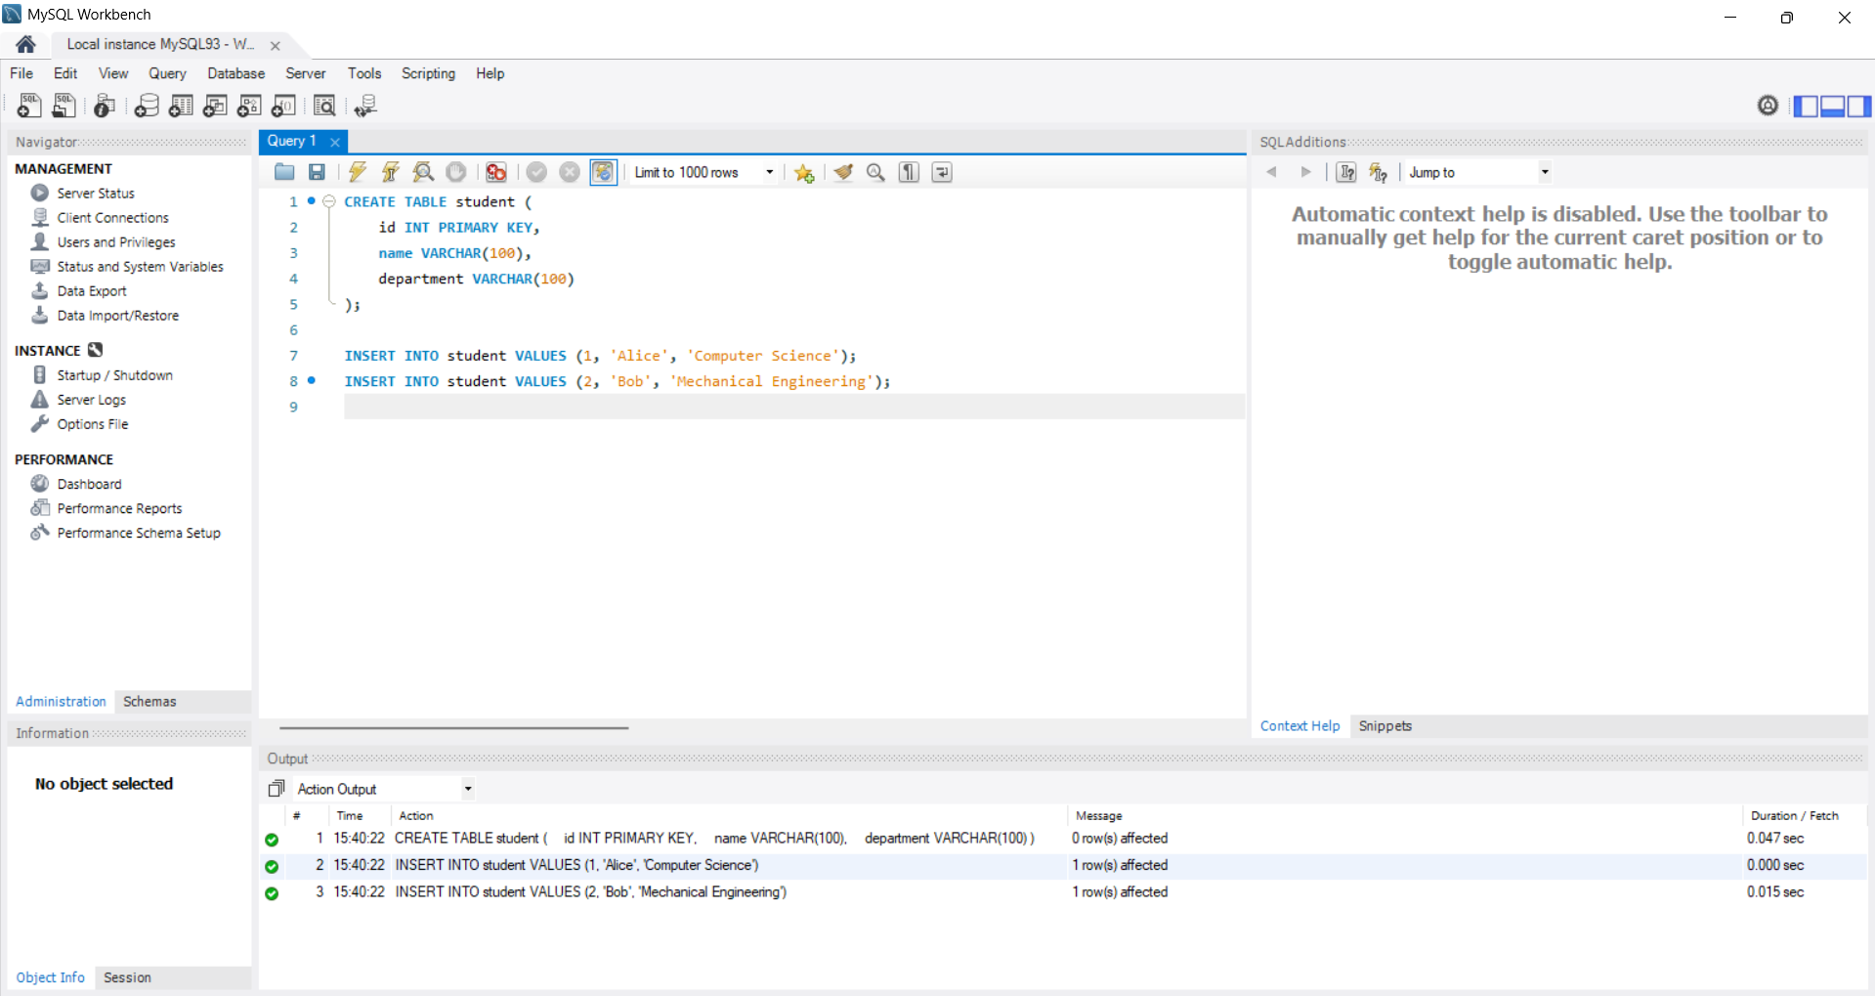

CREATE TABLE student (

id INT PRIMARY KEY,

name VARCHAR(100),

department VARCHAR(100)

);

INSERT INTO student VALUES (1, 'Alice', 'Computer Science');

INSERT INTO student VALUES (2, 'Bob', 'Mechanical Engineering');

**Creating Project in Spring Initializr :**

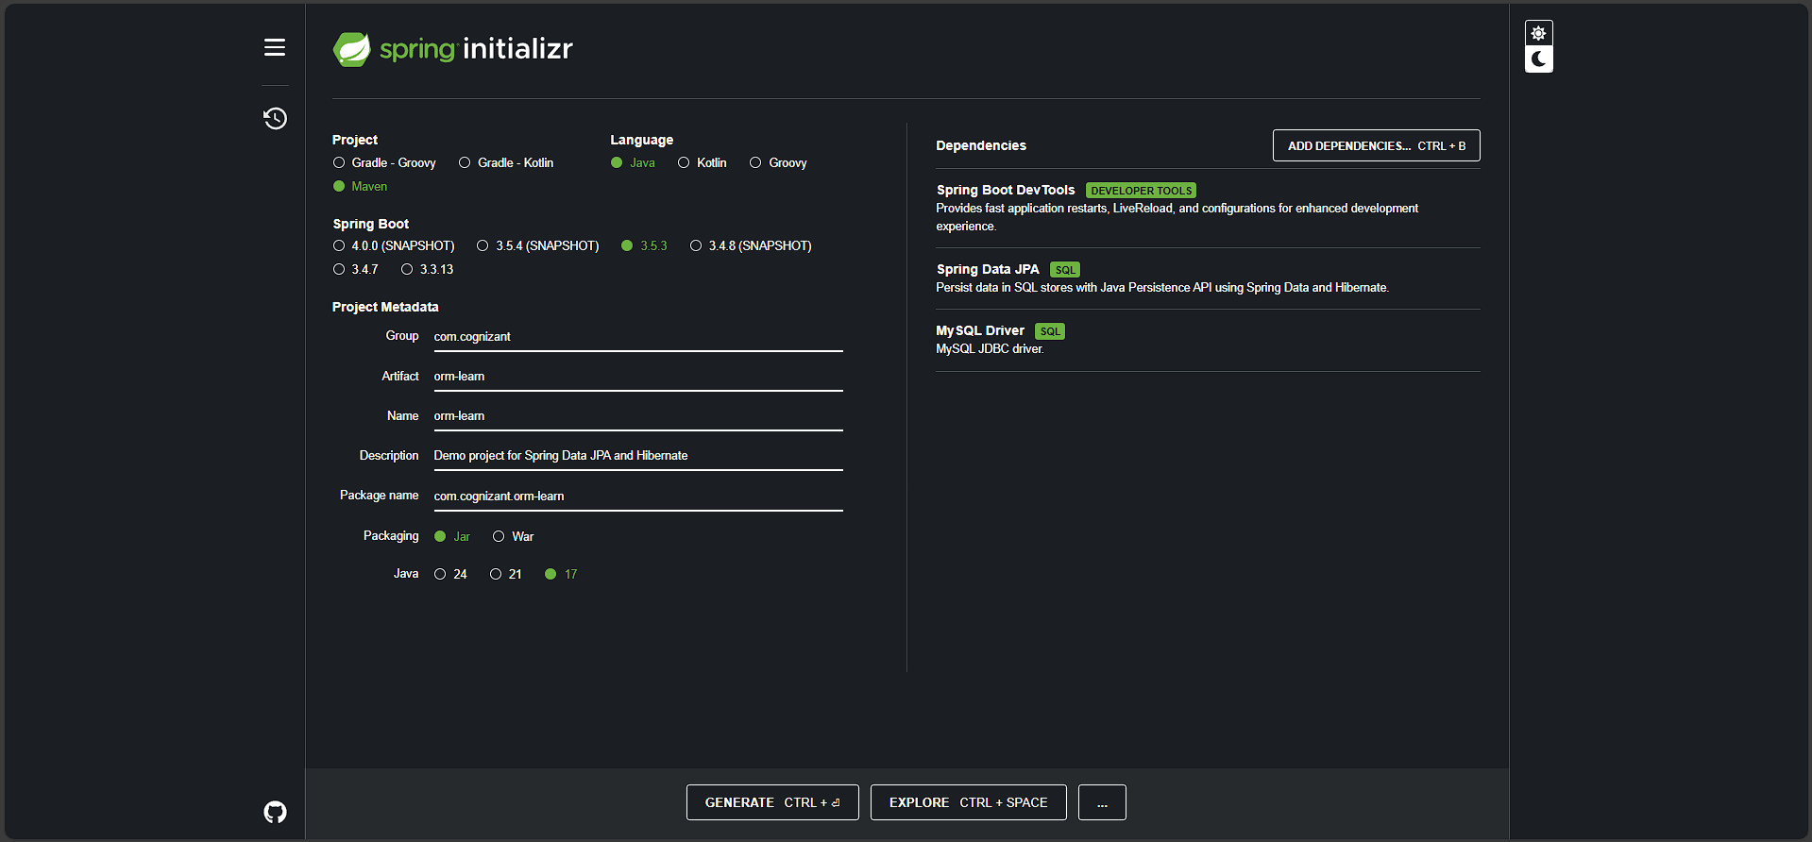

**Application.properties:**

# Logging

logging.level.org.springframework=info logging.level.com.cognizant=debug logging.level.org.hibernate.SQL=debug logging.level.org.hibernate.type.descriptor.sql=trace

# Console log format

logging.pattern.console=%d{dd-MM-yy} %d{HH:mm:ss.SSS} %-20.20thread %5p %-25.25logger{25} %25M %4L %m%n

# Database

spring.datasource.url=jdbc:mysql://localhost:3306/ormlearn spring.datasource.username=root spring.datasource.password=root spring.datasource.driver-class-name=com.mysql.cj.jdbc.Driver

# Hibernate

spring.jpa.hibernate.ddl-auto=validate spring.jpa.properties.hibernate.dialect=org.hibernate.dialect.MySQL5Dialect

**Employee.java:**

package com.example.employeedemo.model;

import jakarta.persistence.*;

@Entity

@Table(name = "employee")

public class Employee {

@Id

@GeneratedValue(strategy = GenerationType.IDENTITY)

private int id;

@Column(name = "name")

private String name;

@Column(name = "department")

private String department;

// Getters and Setters

}

**StudentRepository.java:**

package com.example.employeedemo.repository;

import org.springframework.data.jpa.repository.JpaRepository;

import org.springframework.stereotype.Repository;

import com.example.employeedemo.model.Employee;

@Repository

public interface EmployeeRepository extends JpaRepository<Employee, Integer> {

}

**StudentService.java:**

package com.example.employeedemo.service;

import com.example.employeedemo.model.Employee;

import com.example.employeedemo.repository.EmployeeRepository;

import org.springframework.beans.factory.annotation.Autowired;

import org.springframework.stereotype.Service;

import jakarta.transaction.Transactional;

import java.util.List;

@Service

public class EmployeeService {

@Autowired

private EmployeeRepository employeeRepository;

@Transactional

public void addEmployee(Employee emp) {

employeeRepository.save(emp);

}

public List<Employee> getAllEmployees() {

return employeeRepository.findAll();

}

}

**EmployeeDemoApplication.java:**

@SpringBootApplication

public class EmployeeDemoApplication implements CommandLineRunner {

@Autowired

private EmployeeService employeeService;

private static final Logger LOGGER = LoggerFactory.getLogger(EmployeeDemoApplication.class);

public static void main(String[] args) {

SpringApplication.run(EmployeeDemoApplication.class, args);

}

@Override

public void run(String... args) throws Exception {

Employee emp1 = new Employee();

emp1.setName("Alice");

emp1.setDepartment("HR");

employeeService.addEmployee(emp1);

LOGGER.info("All Employees: {}", employeeService.getAllEmployees());

}

}

OUTPUT:

